Robinson Middle School
2019 Rising 8th Grade Course Selection Instructions

Dear Students and Parents,

This document is a guide to assist you in viewing your online course selections for 8th grade. Please read below and follow the instructions carefully:

- Log onto your SIS student view account. You can click this link to get to the logon page: https://sisstudent.fcps.edu/SVUE/Login_Student_PXP_OVR.aspx.
- Enter your FCPS Network Username (Student ID) and Password. Once you are logged on your screen should look like this:
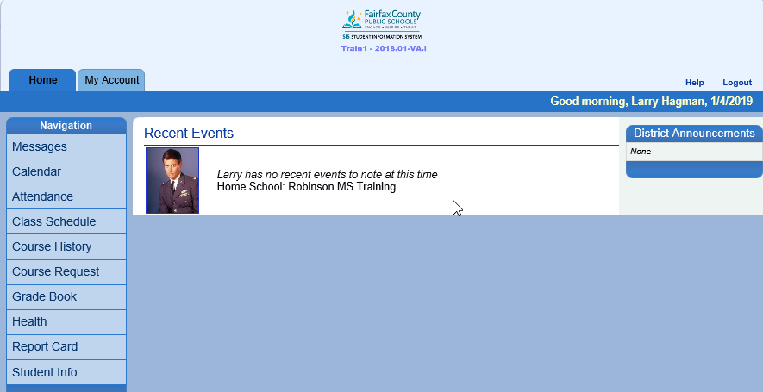

- On the left side bar of the screen, select ‘Course Request’.
- You will see that you are already enrolled in several courses. All students have been pre-enrolled in Civics Honors, Raise, Learning Seminar, and PE Classes (there are 2 PE classes, for 1st and 2nd semesters). You may also see the Math class you are recommended for at this time.
- Students who receive Special Education services or English as a Second Language services will be placed in the correct classes later, after placement decisions are made. Parents will be included in these placement decisions.
- Below is an example of a student Course Request page:

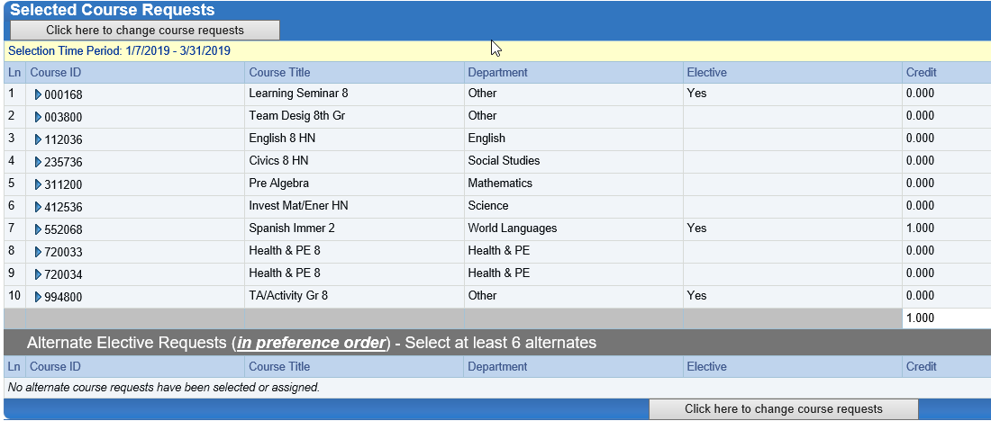
- Core teachers will be completing their recommendations for next year, those classes are being entered and will appear “Locked” in SIS. If you would like to discuss the recommendation, please contact the teacher directly.
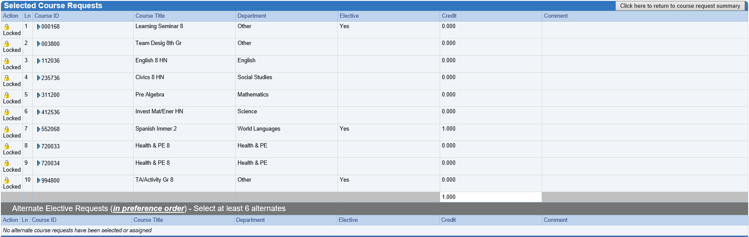
- The week of February 6th-11th, Counselors will be assisting students to enter their elective classes and 6 alternate elective classes
- Once all classes have been entered, and you have discussed any recommendations with the teachers, if you would like to change a class please contact your counselor.

Course Descriptions
- The arrows in red are brief explanations of the courses that you may have questions about. Team Design will tell you what team you are on and what counselor you will have for the 2019-2020 school year. *Teams and specific teachers will not be assigned until later in the summer
- There are 2 PE Sections listed, one for each semester
- TA/ Activity is RAISE
Raise
1st & 2nd Semesters
Team & Counselor

